Machine Learning to Model Mosquito Population Dynamics

Abstract

Surveillance of mosquito populations is essential for developing effective models to study the population dynamics of mosquitoes in the field and for optimizing mosquito management strategies to prevent the transmission of mosquito-borne diseases. Our study in Alabama identified four *Aedes* mosquito species: *Aedes albopictus*, *Aedes triseriatus*, *Aedes japonicus* and *Aedes aegypti*. We found that temperature, daylength, and water vapor pressure were the primary factors influencing mosquito population dynamics. Mosquitoes emerged in March and April, with the largest abundance occurring in August and September. Additionally, using a random forest model, we predicted mosquito populations in the southeastern United States and discovered potential relationships with human population, elevation, and forested cover. In summary, our study provides valuable insights for developing effective mosquito management strategies and introduces a novel approach to predict mosquito populations

Introduction

Mosquitoes are among the most widespread insects, found on every continent except Antarctica and a few islands (Mullen and Durden 2009). They can cause a range of nuisances and dangers to humans, from making noise to transmitting serious diseases during their blood-feeding behavior (Harbach 2007). *Aedes albopictus*, one of the major species in Alabama, has been shown in experiments to be capable of transmitting more than 26 viruses, including serious ones such as dengue virus, zika virus, and chikungunya virus (Paupy et al. 2009). *Ae. albopictus* has been responsible for outbreaks of diseases, such as the chikungunya outbreak in 2005-2007 in the Indian Ocean islands and surrounding countries, and another outbreak in Italy in August 2007 (Angelini et al. 2008, Paupy et al. 2009). *Ae. albopictus* was first recognized in the United States in 1985 in Texas, and has since become established in 866 counties across 26 states (Lambrechts et al. 2010, Bonizzoni et al. 2013). *Ae. triseriatus* (Eastern tree hole mosquito) is another common species found in the United States, distributed from Florida to Idaho (Farajollahi and Price 2013). Additionally, it is the major vector of la cross encephalitis virus, which causes approximately 80 to 100 cases in the United States annually, and it can also spread dengue virus, eastern equine encephalitis, western equine encephalitis, west nile virus, among others (Thompson et al. 1972, Watts et al. 1974, Freier and Grimstad 1983, Platt et al. 2007, Styer et al. 2007, Unlu et al. 2010). *Ae. japonicus*, as an invasive species (Schaffner et al. 2009), was first reported in 1998 in North America (Peyton et al. 1999), and has since been found in 22 states in the United States (Williges et al. 2008). Although, *Ae. japonicas* is not considered a major vector of human pathogens, it can still become infected with west nile virus and la crosse encephalitis, and has been implicated in outbreaks of japanese encephalitis in Asia (Kaufman and Fonseca 2014). Preventing the transmission of human disease pathogens is crucial. Surveillance of mosquito population dynamics is a necessary task to prevent the transmission of mosquito-borne diseases and potential increases in mosquito populations. (Beck-Johnson et al. 2013).

Various methods have been employed for mosquito surveillance, with larval and pupal surveys being more time-consuming and adult surveys difficult to use for large areas due to varying mosquito habitats (CasasMartínez et al. 2013). Resting mosquitoes can be collected directly using aspirator devices, providing information on unfed vs. fed mosquitoes, but it requires a large group of people to focus on one location. BG-Sentinel traps can attract more adult mosquitoes with visual and olfactory baits like light and CO2, but it is expensive to purchase baits and cannot specifically target mosquitoes. In contrast, ovitraps are an easy and cost-effective method for attracting gravid female mosquitoes for egg-laying, providing information on the dynamic changes of mosquito populations (Service 1992). In this study, ovitraps were used to collect mosquito eggs in four cities across Alabama - Montgomery, Tuskegee, Tuscaloosa, and Birmingham - from 2017 to 2023. These eggs were then hatched and reared in a laboratory until they reached the adult stage, allowing for identification and analysis of the mosquitoes.

Mosquito population have been done state-widely in 2004 and 2005 in Alabama through tire larvae sampling and mosquito traps, and identified two common species in *Aedes* genera, *Ae. albopictus*, which is the most common mosquito species, and *Ae. triseriatus*, which name was changed from *Ochlerotatus triseriatus* to *Ae. triseriatus* (Qualls 2005, Qualls and Mullen 2006, 2007). No *Ae. aegypti* was identified from their paper, which confirmed the replacement of *Ae. aegypti* by *Ae. albopictus* in Alabama (Hobbs and Hughes 1991). However, mosquito populations and species changed over decades. In 2017, Dr. Zohdy found the presence of *Ae. aegypti* in Mobile after 26 years of absence (Zohdy et al. 2018). In 2019, Dr. Zohdy collected mosquito in a broad region including 67 counties, but haven’t found the presence of *Ae. aegypti* in all the 67 counties (McKenzie et al. 2019). Therefore, in our study, we keep collecting mosquitoes and only focus on *Aedes* mosquito through ovitraps from 2017 to 2022.

Mosquito population monitoring is a fundamental aspect of investigating mosquito population dynamics in the field, providing valuable information for optimizing mosquito management strategies (Frogner 1980, Service 1985, Juliano 2007). Population modeling is a key tool in this field, enabling researchers to assess the factors that significantly impact population dynamics and to make predictions about future population changes in both time and space. Climate variables are widely known to influence mosquito population dynamics and are commonly used in models for prediction and modeling purposes (Lebl et al. 2013), Both temperature and precipitation have been identified as major contributors to mosquito populations (Beck-Johnson et al. 2013, Abdelrazec and Gumel 2017), daytime length and humidity have also been incorporated into mosquito population models (Buckner et al. 2011, Yamana and Eltahir 2013, Carrieri et al. 2014). wind speed have also been used in the mosquito population modelling recently (Parham et al. 2012, Lebl et al. 2013). Even the cloudiness and desiccation also been investigated in the mosquito population dynamics in some researcheers (Parham et al. 2012). Except the climate variable, other factors like human behavior (Barrera et al. 2011) topography data or landscape factors (streets building blocks, parks, forests and beach) (Buckner et al. 2011, Yamashita et al. 2018). rather than focusing solely on a single species, some researchers have studied multiple species within the same environment (Ezanno et al. 2015).In our study, we constructed both combined and individual models for three species of *Aedes* mosquitoes (*Ae. albopictus*, *Ae. triseriatus*, *Ae. japonicus*) at the same sites based on temperature, daylength, wind speed, precipitation and water vapor pressure.

Various methods have been used to construct models for predicting mosquito populations. Some researchers have used mathematical frameworks or equations that calculate hatching rate, larval growth rate, and larval mortality based on factors such as environmental and geographical conditions (Gong et al. 2007, Yamana and Eltahir 2013, Ewing et al. 2016, Abdelrazec and Gumel 2017, Erraguntla et al. 2021, Whittaker et al. 2022, Beck-Johnson et al. n.d.). However, mathematical frameworks or equations still have limitations in explaining the highly complex data or there is any unknown correlation between independent variables. In constructing the model for mosquito population prediction, the mosquito population data we collected from the field is influenced by numerous factors, including, weather, landmass, water area, human or other small mammal activity, and others, therefore it’s impossible to include all of the variables. so focusing on part of the variables and discarding others through the mathematical equation will result in a higher error in the prediction. To address these issues, some researchers have turned to ensemble learning, which uses multiple learning algorithms instead of just one equation. This provides more accurate prediction without considering the correlation between multiple variables or worryiong about missing some variables. (Joshi and Miller 2021). Maximum entropy modeling was the first approach used for mosquito population modeling and forecasting (Medley 2010). Then SVMs (Support vector machines) have been competitive with Maxent approaches, however, both of them have the problem of limited mosquito population data.(Kerkow et al. 2020). RF (Random Forest) and ANNs (Artificial Neural Networks) is more accurate than SVMs for mosquito modeling (Lee et al. 2016, Ding et al. 2018). Bayesian networks and Fuzzy modeling techniques could also help predict mosquito population. (Murty et al. 2009, Kerkow et al. 2019). Random forest, created by Tin Kam Ho (Ho 1995) and developed by Breiman (Breiman 2001) and Culter (Liaw and Wiener 2013), combines the results from multiple decision trees to produce the most accurace result (Ho 1998). So far, random forest have been used in the mechanism of insecticide resistance (Kortbeek et al. 2021), pest management (Abd El-Ghany et al. 2020), and mosquito population modelling (Lee et al. 2016, Ding et al. 2018).

In this study, we monitored the dynamic changes in the population of Aedes mosquitoes and investigated their relationship with climate factors. Additionally, we constructed a model based on the correlation between changes in mosquito populations and climate factors, and used it to predict mosquito population changes throughout Southeast America.

Material and Method

*Aedes* Mosquito Collection

Infusion

The infusion was used to attract the gravid female mosquitoes to lay their eggs through volatilizing odor, which can be developed using fallen nearly decomposed, dry grass, which was visually confirmed. Leaves and grass were collected from the ground near Auburn University. In total, 20g of leaves and grass and 7g of yeast (Fleischmann’s Rapid Rise) were added to 4 gallons of water. The mixture was fermented in a black, sealed, plastic bucket at an outside location for one week.

Site Collection

Mosquito from Tuskegee, Montgomery, Tuscaloosa, and Birmingham were collected every other week from July 2017 to April 2023. Ovitraps were set near the river, pool or other water areas, and been placed in brush or under trees because larvae and pupae need water to survive and brush or trees can prevent traps being recognized, destroyed, or flushed. (Table1 and Fig. 1). Each location contained 3-4 lidless containers (12cm in height and 11.5cm in diameter) and placed in one basin with a small hole (1cm diameter) to prevent flooding. Containers were filled with 0.7L of the infusion and a U-shaped gap was made on the top edge of the container sides to prevent the rainwater from submerging the paper towel completely. Paper towels were attached to the inside walls of the containers. Gravid female mosquitoes will lay their eggs on the paper towel where the surface of water located.

Rearing Mosquitoes

Mosquitoes were reared at 25±2oC, with an L:D cycle of 12 hours, and they were supplied with a 10% sucrose solution (Liu et al. 2004)

*Aedes spp.* Identification

All identification was based on the book “Keys to the Adult Females and Fourth Instar Larvae of the Mosquitoes of Florida (*Diptera, Culicidae*).”

In *Aedes* spp.: The proboscis is slightly curved; Maxillary palpus is much shorter than proboscis; wing scales are long and narrow; Pale transverse bands or lateral patches basal on abdominal terga.

In *Ae. albopictus*, *Ae. japonicus* and *Ae. triseriatus*, *Ae. triseriatus* has a median, longitudinal stripe of dark brown scales and silvery-white scales laterally, and no white bands on the hindlegs. For *Ae. japonicus*, it has a lyre-shaped pattern on the scutum, and their 4,5 hind tarsomeres are dark-scaled. For *Ae. albopictus*, it has the basal white bands on the 4th hind tarsomeres, and entirely white on the 5th hind tarsomeres. *Ae. albopictus* has only one single narrow strip of white scales on the scutum. Similar as *Ae. japonicus*, *Ae. aegypti* also has lyre shaped pattern on the thorax, but his 5th hind tarsomers is white-scale.

Weather Data

The data on temperature and precipitation of the four collection locations for each month were downloaded from National Centers for Environmental Information (NCEI) website: https://www.ncei.noaa.gov/. The wind speed of the four collection locations for each month was downloaded from the NCEI website and Alabama University. The humidity of the four collection locations for each month was downloaded from timeanddate weather website: https://www.timeanddate.com/weather/usa. The GIS data of different weather variables including temperature, wind speed, precipitation, and water vapor pressure in southeast America were downloaded from https://www.worldclim.org/data/worldclim21.html. In order to correspond with the weather data we got from the GIS data, we convert the humidity to water vapor pressure by R package “humidity”, the unit of temperature from oF to oC, and the unit of precipitation from inches to millimeters by R package “weathermetrics”.

Modeling procedure.

Random forests are considered one of the most effective computational methods to improve unstable estimates, especially when finding a suitable model is challenging due to problem complexity. Predicting mosquito population dynamics using traditional models that rely on simple formulas to examine simple relationships is difficult. However, random forests are better suited to predicting changes in mosquito populations since they do not rely on any single regression formula but use ensemble learning to increase accuracy compared to regression models. In this study, random forests were employed to predict mosquito population changes based on environmental factors.

The mosquito population data was split into two groups: 70% of the data was used for training, and the remaining 30% was used for testing. We generated random forest models using the training data and environmental parameters as independent variables, and assessed the importance of each independent factor based on the increase in mean square errors (InMSE). A larger InMSE value indicates a more important factor. We then used the test data to predict mosquito population based on the environmental factors and calculated the R-square value by comparing the predicted and true data. To eliminate selection bias, we repeated the process of selecting train and test data 100 times. For each time, we built a random forest model, calculated the R-square value, and the InMSE for each environmental factor. Finally, we determined the mean and standard deviation values to evaluate the random forest model and the importance of each environmental factor

Heatmap of mosquito prediction in Southeast of America.

Similar to the approach described above, we also built the random forest model 100 times using the environmental factors collected from NOCAA and predicted the mosquito population each time. Using the mean value of the predictions, we generated a heatmap of mosquito populations in the Southeastern United States.

Analysis

Percentage, mean value, and standard deviation were calculate by R 4.2.2.. Figures were plotted by the software of Graphpad prism8, and R 4.2.2.

Result

Survillance of mosquito population and species in Alabama.

A total of 49,063 mosquitoes was collected near six cities during this research: Tuskegee, Tuscaloosa, Birmingham, Montgomery, Mobile Hunstville, and Dothan. Four species were identified among the population: *Ae. albopictus*, *Ae. japonicus* ,*Ae. triseriatus* and *Ae. aegypti*. *Ae. albopictus* was the primary species in Alabama, accounting for 78.91% of the total mosquito population from the survey, and 38,725 were collected in total. *Ae. japonicus* followed, accounting for 12.78% of the total population, and 6,270 were identified in total. Similar to *Ae. japonicus*, *Ae. triseriatus* also counted 8.18% of the total population, and 4,014 was obtained in total. Except the four major *Aedes spp.*, we also found 54 *Ae.aegypti* in the field, accounting for 0.13% of the total mosquito population from the survey (Table 2). Among the 64 *Ae. aegypti*, only 1 was found in Tuskegee, 42 were found in Montgomery. 5 was found in Tuscaloosa. 6 were found in Birmingham. Tuscaloosa was the city with the larget mosquito population, followed by Montgomery, Tuskegee and Birmingham. Generally, *Ae. albopictus* is outcompete to other two species with 50% portion in all the four cities (54.59% of *Ae. albopictus* in Tuskegee, 94.73% of *Ae. albopictus* in Montgomery, 92.00% of *Ae. albopictus* in Tuscaloosa, 75.00% of *Ae. albopictus* in Birmingham). For the other species, in Tuskgee and Birmingham, the portion of *Ae. triseriatus* and *Ae. japonicus* is over 25% (16.75% of *Ae. japonicus* and 8.20% of *Ae. triseriatus* in Birmingham; 32.17% of *Ae. japonicus* and 13.24% of *Ae. triseriatus* in Tuskegee), in contrast, the portion of *Ae. triseriatus* and *Ae. jponicus* is less than 10% (1.45% of *Ae. japonicus* and 6.54% of *Ae. triseriatus* in Tuscaloosa; 0.86% of *Ae. japonicus* and 4.39% of *Ae. triseriatus* in Montgomery).

Monitoring the mosquito population changes from 2017 to 2023.

We found that August and September were the most abundant months for mosquitoes in Tuskegee, Montgomery, Tuscaloosa, and Birmingham, while March and April were the first months we found mosquito occurrence and start to increase. In order to better observation the relationship between mosquito population changes and environmental factors changes, we summary the mosquito and environmental data with the mean value and standard value of these four years. Based on this figure, we found that mosquito population changes is generally changes with the changes of temperature, daylength, water vapor pressure, and wind speed. However, futher analysis is needed for confirmation.

*Aedes* mosquito species dynamics changes from 2017 to 2023.

To investigate the relationship of the three *Aedes* mosquito we collected, the figure was plotted based on the portion of each species in each month. Based on this figure, In Tuskegee and the first three years of Birmingham, *Ae. japonicus* was the first species emerged in April, and become the predominat species until May when *Ae. albopictus* outcompete other species. However, in Montgomery and Tuscalooosa, *Ae. albopictus* was the first species emerged and the predominant species in the whole year. We found that there is a species shift from *Ae. japonicus* and *Ae. teriseriatus* to *Ae. albopictus* in Tuskegee and the first three years of Birmingham which may because the different species have different suitable environment or *Ae. albopictus* can outcompete other species.

Random forest modeling of mosquito population changes with environmental factors.

We modelling the mosquito population changes with environmental factors through random forest for 100 times. Among the 100 times, the mean value of R square is 0.27 with the standard deviation is 0.13. The MAE is 59.43 with the standard deviation is 6.68. The same pipeline was used for the modelling of each species population changes with environmental factors. For *Ae. albopictus*, the R square is 0.21 (standard deviation 0.21), the MAE is 52.80 (standard deviation 6.35); For *Ae. japonicus*, the R square is 0.03 (standard deviation 0.78), the MAE is 37.67 (standard deviation 6.35); for *Ae. triseriatus*, the R square is 0.06 (standard deviation 0.25), the MAE is 21.43 (standard deviation: 3.14).

We also evaluate the importance of each environmental factors based on their InMSE. Temperature and water vapor pressure are the most importance environmental factors for the whole mosquito population model and *Ae. albopictus* model. In contrast, Temperature and daylength are more important in *Ae. triseriatus* model, and temperature, daylength and water vapor pressure are all important in *Ae. japonicus* model.

Mosquito population prediction in southeast America

Based on our model, we made predictions about changes in mosquito population in southeast America over the course of one year and generated a heatmap. The heatmap shows a gradual increase in mosquito population from January to June and a corresponding decrease from July to December. Moreover, we observed a general north-to-south trend in mosquito population density, with the southern tip of Florida having the highest density and the north of North Carolina having the lowest. We also created similar heatmaps for each *Aedes* species and found that the most abundant months for *Ae. japonicus* and *Ae. triseriatus* are April, May, and June, while for *Ae. albopictus*, the most abundant months are July and August. These results are consistent with our surveillance data, which indicates that the peak population of *Ae. triseriatus* and *Ae. japonicus* occurs earlier than that of *Ae. albopictus*. Furthermore, the populations of *Ae. japonicus* and *Ae. triseriatus* are more concentrated in the northeast, where there are fewer people and more forested areas, whereas *Ae. albopictus* populations are more prevalent in the southwest, where there are more people and less forested areas.

Discussion

Among the three *Aedes* spp. we found in Alabama, *Ae. albopictus* was the most prevalent and was trapped in all locations. It was first reported in 1985 in Texas and has now become established in 866 counties of 26 states (Lambrechts et al. 2010, Bonizzoni et al. 2013). *Ae. triseriatus*, which we found in all the locations ,is a native *Aedes* species, distributed almost throughout the entire United States (Farajollahi and Price 2013). As for Alabama states, *Ae. triseriatus* can be found in most of the counties (Qualls and Mullen 2006). *Ae. japonicus*, which we found in all the locations, was introduced into the northeastern United States in used tires in 1998 (Peyton et al. 1999), and has since extended its range into Georgia, North Carolina, and West Virginia (Gray et al. 2005), West Virginia In Alabama, *Ae. japonicus* females were first identified in a gravid trap in Jackson County by Kristy Gottfried (Mullen 2005). Our study found a higher proportion of *Ae. japonicus* compared to a previous study (Qualls and Mullen 2006), which supports the hypothesis that *Ae. japonicus* may be displacing other mosquito species (Qualls and Mullen 2006).

In our study, we found that *Ae. albopictus* is the most prevalent species and outcompetes other *Aedes* species. Previous studies have also reported that *Ae. albopictus* is the dominant species and a super-competitor to native *Aedes spp*. in Florida (Lounibos et al. 2001, Juliano et al. 2004). Other research has also confirmed the superiority of *Ae. albopictus* when in competition with other species (Paupy et al. 2009), such as *Ae. japonicus* (Armistead et al. 2008), *Ae. triseriatus* (Novak et al. 1993), and *Ae. aegypti* (Braks et al. 2004), because of their higher immature survivorship in all conditions (Petrić et al. 2014), the stronger ability to resist the lack of food (Barrera 1996), positive population growth at higher combined density (Smith et al. 2004), successful survival in the presence of predators, and shorter hatching time (Lounibos et al. 2001).

We found *Ae. aegypti* in all surveyed locations, confirming its presence in Alabama. This species was once the dominant mosquito in Alabama but experienced a rapid decline in 2004 and 2005, being replaced by *Ae. albopictus* (Qualls and Mullen 2006) in Alabama. However, there was a resurgence of *Ae. aegypti* in 2017 in Mobile (Zohdy et al. 2018). Similarly, a state-wide survey in Florida reported the re-detection of *Ae. aegypti* in areas where it had previously gone undetected. Currently, this species is present in more than half of the Florida, whereas in 1995, it was only present in less than half (Parker et al. 2019).

No mosquito eggs were collected until April, when the average temperature was above 14~15°C, which also confirmed by other reasearchers (Kobayashi et al. 2002, Brady et al. 2013). Additionally, diapause may have prevented mosquitoes from emerging before March. Diapause is a method used by mosquitoes and other insects to pass the winter and reproduce in the following spring. It is hormonally programmed in advance and is not immediately stopped in response to suitable conditions. Depending on the species and climate, mosquitoes can successfully survive the winter in the egg, larval, or adult stage. *Aedes spp.,* for example, typically overwinter in the egg stage (Denlinger et al. 2012, Denlinger and Armbruster 2014). The mechanism of diapause is still unclear, however, photoperiod (Pumpuni et al. 1992, Mathias et al. 2007), temperature (Pumpuni et al. 1992), changes of hormone concentration (Denlinger et al. 2012), specific gene expression (Mathias et al. 2007) et al., are the factors influenced diapause. Our study found that the largest mosquito abundance occurred when the average temperature was 25oC~30oC August or September. Other studies also confirmed the suitable temperature of mosquitoes should be in the range of 20oC ~ 30oC (Alto and Juliano 2001, Yang et al. 2009, Beck-Johnson et al. 2013, Brady et al. 2013), which allows for greater intrinsic rates (Alto and Juliano 2001) and optimal survival rate (Brady et al. 2013).

According to our random forest modeling, temperature, day length, and water vapor pressure were found to be the major factors influencing the dynamics of mosquito populations. We converted humidity to water vapor pressure to be consistent with the weather data from GIS, so humidity also affects the dynamics of mosquito populations. temperature has been confirmed to influence the mosquito population dynamics, as higher temperatures can decrease embryonic and larval development time (Rueda et al. 1990, Teng and Apperson 2000, Alto and Juliano 2001). However, excessively high temperatures (>35oC) may decrease the hatching rate of eggs and adult size, thereby affecting mosquito survival (Rueda et al. 1990, Yang et al. 2009, Mohammed and Chadee 2011). In addition, humidity has also been confirmed to be related to the dynamics of mosquito population, as high relative humidity contributes to a greater mosquito population than low relative humidity, since it is helpful for female mosquitoes to lay more eggs and increases the opportunity for mosquito survival (Canyon et al. 1999, Madeira et al. 2002, Costa et al. 2010). Daylength also been confirmed relate to the dynamics of mosquito population. Other research has confirmed that day length has significant effects on various aspects of mosquito biology, such as female survival, blood-feeding activity, development time, adult size, fecundity, and adult lifespan. These factors can have an impact on mosquito population dynamics (Costanzo et al. 2015, Peffers et al. 2021).

We not only generated a heatmap of mosquito population predictions but also a corresponding elevation heatmap. We have discovered a correlation between mosquito population and elevation. Specifically, the mosquito population was significantly lower around the Appalachian mountain area than in the surrounding areas. This finding is consistent with other research which highlights the importance of elevation in mosquito distribution and population dynamics (Ahumada et al. 2004, Wang et al. 2015). We also generated a heatmap of human population and observed that areas with larger human populations had a higher mosquito population, even at the same elevation. For example, in Florida, the mosquito population was greater in Miami compared to surrounding areas. This trend can be attributed to a large number of humans and extensive urbanization, which provide abundant blood meals and breeding sites, particularly for *Ae. albopictus*. Other researchers have also confirmed the significance of human population in predicting mosquito population dynamics (Slosek 1986, Carbajo et al. 2006, Petrić et al. 2014, Obenauer et al. 2017). Additionally, a higher mosquito population increases the risk of the prevalence of mosquito-borne diseases (Smith et al. 2004). We also examined the relationship between tree cover and the predicted populations of three *Aedes* species. Our analysis revealed that *Ae. triseriatus* and *Ae. japonicus* tend to be more abundant in forested areas, while *Ae. albopictus* is more prevalent in human-populated areas. This pattern is consistent with the ecological preferences of these species, as *Ae. triseriatus* and *Ae. japonicus* breed in natural water containers found in forested habitats, while *Ae. albopictus* is highly adapted to urban and suburban environments. The ability of *Ae. triseriatus* and *Ae. japonicus* to thrive in forests may be due to their ability to avoid competition with *Ae. albopictus* (Novak et al. 1993, Barker et al. 2003, Armistead et al. 2008, Kaufman and Fonseca 2014).

Our study revealed the presence of *Ae. aegypti* in Alabama, but *Ae. albopictus* remains the predominant species. Additionally, our findings indicate that the peak mosquito population occurs in August and September. Using a random forest model, we identified temperature, water vapor pressure, and day length as important factors for mosquito population dynamics. Furthermore, we generated a heatmap predicting mosquito populations in the Southeastern United States and found potential relationships with human population, tree cover, and elevation. Overall, our study provides valuable information for developing effective mosquito management strategies and introduces a novel modeling approach for predicting mosquito populations.

Reference

**Abd El-Ghany, N. M., S. E. Abd El-Aziz, and S. S. Marei**. **2020**. A review: application of remote sensing as a promising strategy for insect pests and diseases management. Environ Sci Pollut Res. 27: 33503–33515.

**Abdelrazec, A., and A. B. Gumel**. **2017**. Mathematical assessment of the role of temperature and rainfall on mosquito population dynamics. J. Math. Biol. 74: 1351–1395.

**Ahumada, J. A., D. Laoointe, and M. D. Samuel**. **2004**. Modeling the Population Dynamics of Culex quinquefasciatus (Diptera: Culicidae), along an Elevational Gradient in Hawaii. Journal of Medical Entomology. 41: 1157–1170.

**Alto, B. W., and S. A. Juliano**. **2001**. Temperature effects on the dynamics of Aedes albopictus (Diptera: Culicidae) populations in the laboratory. Journal of medical entomology. 38: 548–556.

**Angelini, P., P. Macini, A. C. Finarelli, C. Po, C. Venturelli, R. Bellini, and M. Dottori**. **2008**. Chikungunya epidemic outbreak in Emilia-Romagna (Italy) during summer 2007. Parassitologia. 50: 97.

**Armistead, J. S., J. R. Arias, N. Nishimura, and L. P. Lounibos**. **2008**. Interspecific Larval Competition Between Aedes albopictus and Aedes japonicus (Diptera: Culicidae) in Northern Virginia. J Med Entomol. 45: 629–637.

**Barker, C. M., S. L. Paulson, S. Cantrell, and B. S. Davis**. **2003**. Habitat Preferences and Phenology of Ochlerotatus triseriatus and Aedes albopictus (Diptera: Culicidae) in Southwestern Virginia. J Med Entomol. 40: 403–410.

**Barrera, R.** **1996**. Competition and resistance to starvation in larvae of container-inhabiting Aedes mosquitoes. Ecological Entomology. 21: 117–127.

**Barrera, R., M. Amador, and A. J. MacKay**. **2011**. Population Dynamics of Aedes aegypti and Dengue as Influenced by Weather and Human Behavior in San Juan, Puerto Rico. PLOS Neglected Tropical Diseases. 5: e1378.

**Beck-Johnson, L. M., W. A. Nelson, K. P. Paaijmans, A. F. Read, M. B. Thomas, and O. N. Bjørnstad**. **2013**. The Effect of Temperature on Anopheles Mosquito Population Dynamics and the Potential for Malaria Transmission. PLOS ONE. 8: e79276.

**Beck-Johnson, L. M., W. A. Nelson, K. P. Paaijmans, A. F. Read, M. B. Thomas, and O. N. Bjørnstad**. **n.d.** The importance of temperature fluctuations in understanding mosquito population dynamics and malaria risk. Royal Society Open Science. 4: 160969.

**Bonizzoni, M., G. Gasperi, X. Chen, and A. A. James**. **2013**. The invasive mosquito species Aedes albopictus: current knowledge and future perspectives. Trends in Parasitology. 29: 460–468.

**Brady, O. J., M. A. Johansson, C. A. Guerra, S. Bhatt, N. Golding, D. M. Pigott, H. Delatte, M. G. Grech, P. T. Leisnham, R. Maciel-de-Freitas, L. M. Styer, D. L. Smith, T. W. Scott, P. W. Gething, and S. I. Hay**. **2013**. Modelling adult Aedes aegypti and Aedes albopictus survival at different temperatures in laboratory and field settings. Parasites & Vectors. 6: 351.

**Braks, M. a. H., N. A. Honório, L. P. Lounibos, R. Lourenço-De-Oliveira, and S. A. Juliano**. **2004**. Interspecific Competition Between Two Invasive Species of Container Mosquitoes, Aedes aegypti and Aedes albopictus (Diptera: Culicidae), in Brazil. Ann Entomol Soc Am. 97: 130–139.

**Breiman, L.** **2001**. Random Forests. Machine Learning. 45: 5–32.

**Buckner, E. A., M. S. Blackmore, S. W. Golladay, and A. P. Covich**. **2011**. Weather and landscape factors associated with adult mosquito abundance in southwestern Georgia, U.S.A. Journal of Vector Ecology. 36: 269–278.

**Canyon, D. V., J. L. K. Hii, and R. Müller**. **1999**. Adaptation of Aedes aegypti (Diptera: Culicidae) oviposition behavior in response to humidity and diet. Journal of Insect Physiology. 45: 959–964.

**Carbajo, A. E., S. I. Curto, and N. J. Schweigmann**. **2006**. Spatial distribution pattern of oviposition in the mosquito Aedes aegypti in relation to urbanization in Buenos Aires: southern fringe bionomics of an introduced vector. Medical and Veterinary Entomology. 20: 209–218.

**Carrieri, M., P. Fariselli, B. Maccagnani, P. Angelini, M. Calzolari, and R. Bellini**. **2014**. Weather Factors Influencing the Population Dynamics of Culex pipiens (Diptera: Culicidae) in the Po Plain Valley, Italy (1997-2011). Environmental Entomology. 43: 482–490.

**CasasMartínez, M., A. OrozcoBonilla, M. MuñozReyes, A. UlloaGarcía, J. G. Bond, J. ValleMora, M. Weber, and J. C. Rojas**. **2013**. A new tent trap for monitoring the daily activity of Aedes aegypti and Aedes albopictus. Journal of Vector Ecology. 38: 277–288.

**Costa, E. A. P. de A., E. M. de M. Santos, J. C. Correia, and C. M. R. de Albuquerque**. **2010**. Impact of small variations in temperature and humidity on the reproductive activity and survival of Aedes aegypti (Diptera, Culicidae). Revista Brasileira de Entomologia. 54: 488–493.

**Costanzo, K. S., S. Schelble, K. Jerz, and M. Keenan**. **2015**. The effect of photoperiod on life history and blood-feeding activity in Aedes albopictus and Aedes aegypti (Diptera: Culicidae). Journal of Vector Ecology. 40: 164–171.

**Denlinger, D. L., and P. A. Armbruster**. **2014**. Mosquito Diapause. Annual Review of Entomology. 59: 73–93.

**Denlinger, D. L., G. D. Yocum, and J. P. Rinehart**. **2012**. 10 - Hormonal Control of Diapause, pp. 430–463. *In* Gilbert, L.I. (ed.), Insect Endocrinology. Academic Press, San Diego.

**Ding, F., J. Fu, D. Jiang, M. Hao, and G. Lin**. **2018**. Mapping the spatial distribution of Aedes aegypti and Aedes albopictus. Acta Tropica. 178: 155–162.

**Erraguntla, M., D. Dave, J. Zapletal, K. Myles, Z. N. Adelman, T. D. Pohlenz, and M. Lawley**. **2021**. Predictive model for microclimatic temperature and its use in mosquito population modeling. Sci Rep. 11: 18909.

**Ewing, D. A., C. A. Cobbold, B. V. Purse, M. A. Nunn, and S. M. White**. **2016**. Modelling the effect of temperature on the seasonal population dynamics of temperate mosquitoes. Journal of Theoretical Biology. 400: 65–79.

**Ezanno, P., M. Aubry-Kientz, S. Arnoux, P. Cailly, G. L’Ambert, C. Toty, T. Balenghien, and A. Tran**. **2015**. A generic weather-driven model to predict mosquito population dynamics applied to species of Anopheles, Culex and Aedes genera of southern France. Preventive Veterinary Medicine, 2nd International Conference on Animal Health Surveillance (ICAHS). 120: 39–50.

**Farajollahi, A., and D. C. Price**. **2013**. A Rapid Identification Guide for Larvae of the Most Common North American Container-Inhabiting Aedes Species of Medical Importance. moco. 29: 203–221.

**Freier, J. E., and P. R. Grimstad**. **1983**. Transmission of Dengue Virus by Orally Infected Aedes Triseriatus*. The American Journal of Tropical Medicine and Hygiene. 32: 1429–1434.

**Frogner, K. J.** **1980**. Variable Developmental Period: Intraspecific Competition Models with Conditional Age-Specific Maturity and Mortality Schedules. Ecology. 61: 1099–1106.

**Gong, H., A. De Gaetano, and L. Harrington**. **2007**. A climate based mosquito population model, pp. 24–27. *In* Proceedings of the World Congress on Engineering and Computer Science.

**Gray, E. W., B. A. Harrison, M. L. Womack, J. Kerce, C. J. Neely, and R. Noblet**. **2005**. OCHLEROTATUS JAPONICUS JAPONICUS (THEOBALD) IN GEORGIA AND NORTH CAROLINA. moco. 21: 144–146.

**Harbach, R. E.** **2007**. The Culicidae (Diptera): a review of taxonomy, classification and phylogeny*. Zootaxa. 1668: 591–638.

**Ho, T. K.** **1995**. Random decision forests, pp. 278–282 vol.1. *In* Proceedings of 3rd International Conference on Document Analysis and Recognition. Presented at the Proceedings of 3rd International Conference on Document Analysis and Recognition.

**Ho, T. K.** **1998**. The random subspace method for constructing decision forests. IEEE Transactions on Pattern Analysis and Machine Intelligence. 20: 832–844.

**Hobbs, J. H., and E. A. Hughes**. **1991**. Replacement of Aedes aegypti by Aedes albopictus in Mobile, Alabama. Journal of the American Mosquito Control Association. 7: 488–489.

**Joshi, A., and C. Miller**. **2021**. Review of machine learning techniques for mosquito control in urban environments. Ecological Informatics. 61: 101241.

**Juliano, S. A.** **2007**. Population Dynamics. J Am Mosq Control Assoc. 23: 265–275.

**Juliano, S. A., L. P. Lounibos, and G. F. O’Meara**. **2004**. A field test for competitive effects of Aedes albopictus on A-aegypti in South Florida: differences between sites of coexistence and exclusion? Oecologia. 139: 583–593.

**Kaufman, M. G., and D. M. Fonseca**. **2014**. Invasion Biology of Aedes japonicus japonicus (Diptera: Culicidae). Annual Review of Entomology. 59: 31–49.

**Kerkow, A., R. Wieland, L. Früh, F. Hölker, J. M. Jeschke, D. Werner, and H. Kampen**. **2020**. Can data from native mosquitoes support determining invasive species habitats? Modelling the climatic niche of Aedes japonicus japonicus (Diptera, Culicidae) in Germany. Parasitol Res. 119: 31–42.

**Kerkow, A., R. Wieland, M. B. Koban, F. Hölker, J. M. Jeschke, D. Werner, and H. Kampen**. **2019**. What makes the Asian bush mosquito Aedes japonicus japonicus feel comfortable in Germany? A fuzzy modelling approach. Parasites & Vectors. 12: 106.

**Kobayashi, M., N. Nihei, and T. Kurihara**. **2002**. Analysis of Northern Distribution of Aedes albopictus (Diptera: Culicidae) in Japan by Geographical Information System. J Med Entomol. 39: 4–11.

**Kortbeek, R. W. J., M. D. Galland, A. Muras, F. M. van der Kloet, B. André, M. Heilijgers, S. A. F. T. van Hijum, M. A. Haring, R. C. Schuurink, and P. M. Bleeker**. **2021**. Natural variation in wild tomato trichomes; selecting metabolites that contribute to insect resistance using a random forest approach. BMC Plant Biol. 21: 315.

**Lambrechts, L., T. W. Scott, and D. J. Gubler**. **2010**. Consequences of the Expanding Global Distribution of Aedes albopictus for Dengue Virus Transmission. PLOS Neglected Tropical Diseases. 4: e646.

**Lebl, K., K. Brugger, and F. Rubel**. **2013**. Predicting Culex pipiens/restuans population dynamics by interval lagged weather data. Parasites Vectors. 6: 129.

**Lee, K. Y., N. Chung, and S. Hwang**. **2016**. Application of an artificial neural network (ANN) model for predicting mosquito abundances in urban areas. Ecological Informatics. 36: 172–180.

**Liaw, A., and M. Wiener**. **2013**. Documentation for R package randomForest. PDF). Retrieved. 15: 191.

**Liu, H., E. W. Cupp, K. M. Micher, A. Guo, and N. Liu**. **2004**. Insecticide Resistance and Cross-Resistance in Alabama and Florida Strains of Culex quinquefaciatus. J Med Entomol. 41: 408–413.

**Lounibos, L. P., G. F. O’Meara, R. L. Escher, N. Nishimura, M. Cutwa, T. Nelson, R. E. Campos, and S. A. Juliano**. **2001**. Testing Predictions of Displacement of Native Aedes by the Invasive Asian Tiger Mosquito Aedes Albopictus in Florida, USA. Biological Invasions. 3: 151–166.

**Madeira, N. G., C. A. Macharelli, and L. R. Carvalho**. **2002**. Variation of the Oviposition Preferences of Aedes aegypti in Function of Substratum and Humidity. Memórias do Instituto Oswaldo Cruz. 97: 415–420.

**Mathias, D., L. Jacky, W. E. Bradshaw, and C. M. Holzapfel**. **2007**. Quantitative Trait Loci Associated with Photoperiodic Response and Stage of Diapause in the Pitcher-Plant Mosquito, Wyeomyia smithii. Genetics. 176: 391–402.

**McKenzie, B. A., K. Stevens, A. E. McKenzie, J. Bozic, D. Mathias, and S. Zohdy**. **2019**. Aedes Vector Surveillance in the Southeastern United States Reveals Growing Threat of Aedes japonicus japonicus (Diptera: Culicidae) and Aedes albopictus. Journal of Medical Entomology. 56: 1745–1749.

**Medley, K. A.** **2010**. Niche shifts during the global invasion of the Asian tiger mosquito, Aedes albopictus Skuse (Culicidae), revealed by reciprocal distribution models. Global Ecology and Biogeography. 19: 122–133.

**Mohammed, A., and D. D. Chadee**. **2011**. Effects of different temperature regimens on the development of Aedes aegypti (L.) (Diptera: Culicidae) mosquitoes. Acta Tropica. 119: 38–43.

**Mullen, G. R.** **2005**. First report of Ochlerotatus japonicus in Alabama. Ala. Vector Manage. Soc. Newsl. 15: 2.

**Mullen, G. R., and L. A. Durden**. **2009**. Medical and Veterinary Entomology. Academic Press.

**Murty, U. S., M. S. Rao, and N. Arunachalam**. **2009**. Prediction of Japanese Encephalitis Vectors in Kurnool District of Andhra Pradesh, India by Using Bayesian Network. Applied Artificial Intelligence. 23: 828–834.

**Novak, M. G., L. G. Higley, C. A. Christianssen, and W. A. Rowley**. **1993**. Evaluating Larval Competition Between Aedes albopictus and A. triseriatus (Diptera: Culicidae) through Replacement Series Experiments. Environ Entomol. 22: 311–318.

**Obenauer, J. F., T. Andrew Joyner, and J. B. Harris**. **2017**. The importance of human population characteristics in modeling Aedes aegypti distributions and assessing risk of mosquito-borne infectious diseases. Tropical Medicine and Health. 45: 38.

**Parham, P. E., D. Pople, C. Christiansen-Jucht, S. Lindsay, W. Hinsley, and E. Michael**. **2012**. Modeling the role of environmental variables on the population dynamics of the malaria vector Anopheles gambiae sensu stricto. Malaria Journal. 11: 271.

**Parker, C., D. Ramirez, and C. R. Connelly**. **2019**. State-wide survey of Aedes aegypti and Aedes albopictus (Diptera: Culicidae) in Florida. Journal of Vector Ecology. 44: 210–215.

**Paupy, C., H. Delatte, L. Bagny, V. Corbel, and D. Fontenille**. **2009**. Aedes albopictus, an arbovirus vector: From the darkness to the light. Microbes and Infection, Forum on Chikungunya. 11: 1177–1185.

**Peffers, C. S., L. W. Pomeroy, and M. E. Meuti**. **2021**. Critical Photoperiod and Its Potential to Predict Mosquito Distributions and Control Medically Important Pests. Journal of Medical Entomology. 58: 1610–1618.

**Petrić, D., R. Bellini, E.-J. Scholte, L. M. Rakotoarivony, and F. Schaffner**. **2014**. Monitoring population and environmental parameters of invasive mosquito species in Europe. Parasites & Vectors. 7: 187.

**Peyton, E. L., S. R. Campbell, T. M. Candeletti, M. Romanowski, and W. J. Crans**. **1999**. Aedes (Finlaya) Japonicus Japonicus (Theobald), A New Introduction into the United States. WALTER REED BIOSYSTEMATICS UNIT WASHINGTON DC.

**Platt, K. B., B. J. Tucker, P. G. Halbur, S. Tiawsirisup, B. J. Blitvich, F. G. Fabiosa, L. C. Bartholomay, and W. A. Rowley**. **2007**. West Nile Virus Viremia in Eastern Chipmunks (Tamias striatus) Sufficient for Infecting Different Mosquitoes. Emerg Infect Dis. 13: 831–837.

**Pumpuni, C. B., J. Knepler, and J. G. Craig**. **1992**. Influence of temperature and larval nutrition on the diapause inducing photoperiod of Aedes albopictus. J Am Mosq Control Assoc. 8: 223–227.

**Qualls, W.** **2005**. Field Studies and Monitoring of Mosquito Populations (Diptera:Culicidae) in Urban Envrionments (Thesis).

**Qualls, W. A., and G. R. Mullen**. **2006**. LARVAL SURVEY OF TIRE-BREEDING MOSQUITOES IN ALABAMA. moco. 22: 601–608.

**Qualls, W. A., and G. R. Mullen**. **2007**. EVALUATION OF THE MOSQUITO MAGNET PROTM TRAP WITH AND WITHOUT 1-OCTEN-3-OL FOR COLLECTING AEDES ALBOPICTUS AND OTHER URBAN MOSQUITOES. moco. 23: 131–136.

**Rueda, L. M., K. J. Patel, R. C. Axtell, and R. E. Stinner**. **1990**. Temperature-Dependent Development and Survival Rates of Culex quinquefasciatus and Aedes aegypti (Diptera: Culicidae). J Med Entomol. 27: 892–898.

**Service, M. W.** **1985**. Population dynamics and mortalities of mosquito preadults, pp. 185–201. *In* Ecology of Mosquitoes: Proceedings of a Workshop. Florida Medical Entomology Laboratory Vero Beach, Florida.

**Service, M. W.** **1992**. Importance of ecology in Aedes aegypti control. Southeast Asian J. Trop. Med. Public Health. 23: 681–690.

**Slosek, J.** **1986**. Aedes aegypti mosquitoes in the Americas: A review of their interactions with the human population. Social Science & Medicine. 23: 249–257.

**Smith, D. L., J. Dushoff, and F. E. McKenzie**. **2004**. The Risk of a Mosquito-Borne Infectionin a Heterogeneous Environment. PLOS Biology. 2: e368.

**Styer, L. M., K. A. Kent, R. G. Albright, C. J. Bennett, L. D. Kramer, and K. A. Bernard**. **2007**. Mosquitoes Inoculate High Doses of West Nile Virus as They Probe and Feed on Live Hosts. PLOS Pathogens. 3: e132.

**Teng, H.-J., and C. S. Apperson**. **2000**. Development and Survival of Immature Aedes albopictus and Aedes triseriatus (Diptera: Culicidae) in the Laboratory: Effects of Density, Food, and Competition on Response to Temperature. J Med Entomol. 37: 40–52.

**Thompson, W. H., R. O. Anslow, R. P. Hanson, and G. R. Defoliart**. **1972**. La Crosse Virus Isolations from Mosquitoes in Wisconsin, 1964–68*. The American Journal of Tropical Medicine and Hygiene. 21: 90–96.

**Unlu, I., A. J. Mackay, A. Roy, M. M. Yates, and L. D. Foil**. **2010**. Evidence of vertical transmission of West Nile virus in field-collected mosquitoes. Journal of Vector Ecology. 35: 95–99.

**Wang, Y., D. Zhong, L. Cui, M.-C. Lee, Z. Yang, G. Yan, and G. Zhou**. **2015**. Population dynamics and community structure of Anopheles mosquitoes along the China-Myanmar border. Parasites & Vectors. 8: 445.

**Watts, D. M., W. H. Thompson, T. M. Yuill, G. R. DeFoliart, and R. P. Hanson**. **1974**. Overwintering of La Crosse Virus in Aedes Triseriatus*. The American Journal of Tropical Medicine and Hygiene. 23: 694–700.

**Whittaker, C., P. Winskill, M. Sinka, S. Pironon, C. Massey, D. J. Weiss, M. Nguyen, P. W. Gething, A. Kumar, A. Ghani, and S. Bhatt**. **2022**. A novel statistical framework for exploring the population dynamics and seasonality of mosquito populations. Proceedings of the Royal Society B: Biological Sciences. 289: 20220089.

**Williges, E., A. Farajollahi, J. J. Scott, L. J. Mccuiston, W. J. Crans, and R. Gaugler**. **2008**. Laboratory Colonization of Aedes japonicus japonicus. moco. 24: 591–593.

**Yamana, T. K., and E. A. B. Eltahir**. **2013**. Incorporating the effects of humidity in a mechanistic model of Anopheles gambiae mosquito population dynamics in the Sahel region of Africa. Parasites & Vectors. 6: 235.

**Yamashita, W. M. S., S. S. Das, and G. Chapiro**. **2018**. Numerical modeling of mosquito population dynamics of Aedes aegypti. Parasites & Vectors. 11: 245.

**Yang, H. M., M. L. G. Macoris, K. C. Galvani, M. T. M. Andrighetti, and D. M. V. Wanderley**. **2009**. Assessing the effects of temperature on the population of Aedes aegypti, the vector of dengue. Epidemiology & Infection. 137: 1188–1202.

**Zohdy, S., W. C. Morse, D. Mathias, V. Ashby, and S. Lessard**. **2018**. Detection of Aedes (Stegomyia) aegypti (Diptera: Culicidae) Populations in Southern Alabama Following a 26-yr Absence and Public Perceptions of the Threat of Zika Virus. J. Med. Entomol. 55: 1319–1324.

**Table 1.** : Trap ID and Locations

|  |  |  |  |
| --- | --- | --- | --- |
| **Trap ID** | **Latitude** | **Longitude** | **Nearby Street** |
| Tuskegee | 32.428 | -85.676 | Macon Dr. |
| Montgomery 17 | 32.375 | -86.326 | Herron St. |
| Tuscaloosa 17a | 33.211 | -87.576 | Jack Warner Pkwy |
| Tuscaloosa 17b | 33.210 | -87.577 | Jack Warner Pkwy |
| Birmingham 17 | 33.403 | -86.665 | Farley Ln |
| Montgomery 18 & 19 | 32.394 | -86.314 | Abbie St |
| Tuscaloosa 18 & 19 | 33.215 | -87.566 | 21st Ave |
| Birmingham 18 & 19 | 33.377 | -86.668 | Mountain Top Rd |
|  |  |  |  |

|  |  |  |  |  |  |  |  |  |  |  |  |  |
| --- | --- | --- | --- | --- | --- | --- | --- | --- | --- | --- | --- | --- |
| **Location** | **Species** | | | | | | | | | | | **Total Number** |
| *Aedes albopictus* | |  | *Aedes triseriatus* | |  | *Aedes japonicus* | |  | *Aedes aegypti* | |
| Number | Percentage* |  | Number | Percentage* |  | Number | Percentage* |  | Number | Percentage* |
| Tuskegee | 7403 | 54.59% |  | 1795 | 13.24% |  | 4363 | 32.17% |  | 1 | 0.01% | 13562 |
| Montgomery | 11520 | 94.40% |  | 536 | 4.39% |  | 105 | 0.86% |  | 42 | 0.34% | 12203 |
| Tuscaloosa | 12642 | 91.97% |  | 899 | 6.54% |  | 200 | 1.45% |  | 5 | 0.04% | 13746 |
| Brimingham | 7160 | 74.88% |  | 784 | 8.20% |  | 1602 | 16.75% |  | 16 | 0.17% | 9562 |
| **In Total** | 38725 | 78.91% |  | 4014 | 8.18% |  | 6270 | 12.78% |  | 64 | 0.13% | 49073 |

Table 2.: Total population of *Aedes* mosquitoes collected in Alabama from 2017-2019

* Percentage is calculated by the number of each species by total population.

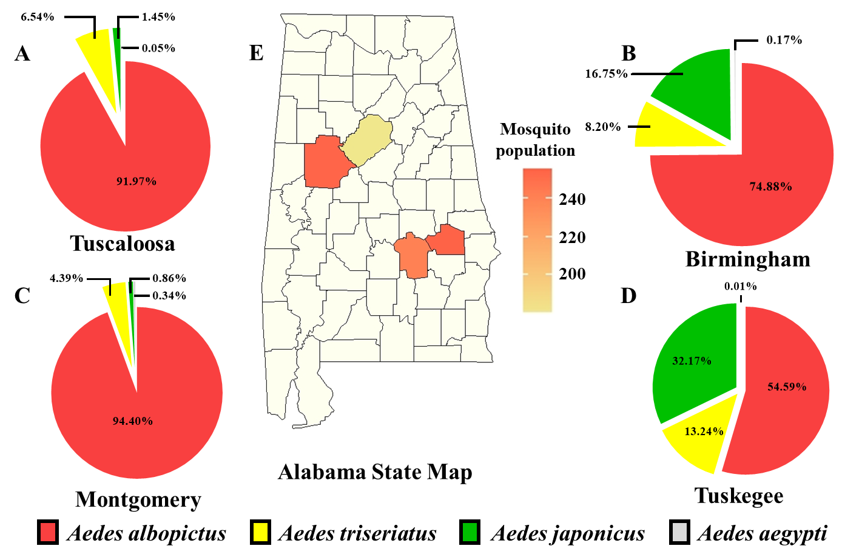

Fig. 6. *Aedes* mosquito populations and species in six countries of Alabama. Species in Tuscaloosa (A), Montgomery (B), Mobile (C), Birmingham (D), Tuskegee (E), and Dothan (F). (H) Heatmap of the mosquito population in Tuskegee, Tuscaloosa, Montgomery, Birmingham, Dothan, and Mobile.

* This is the average number of one trap in one month.



**Fig. 7**. The proportion of mosquito species in different location collected in Alabama from 2017 to 2019.

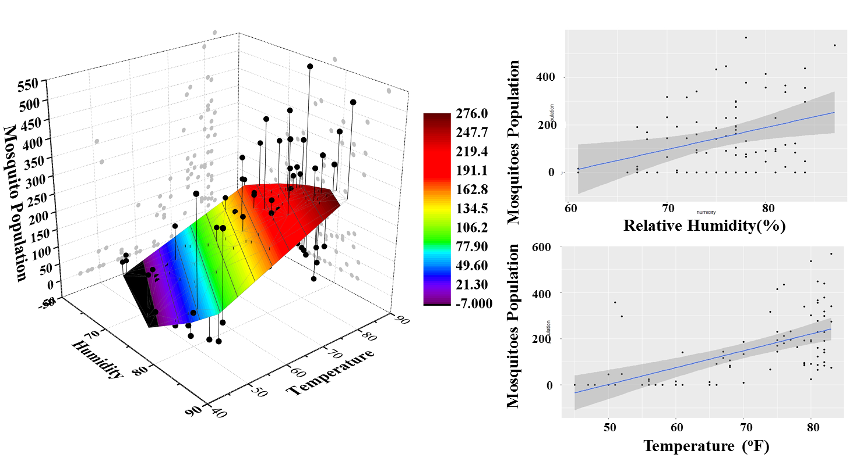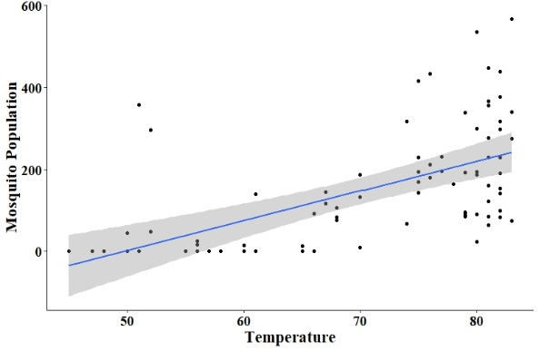

P =4.68e-10

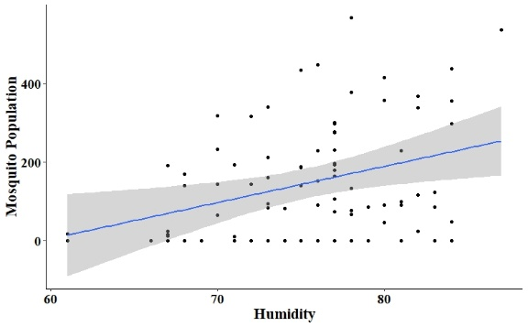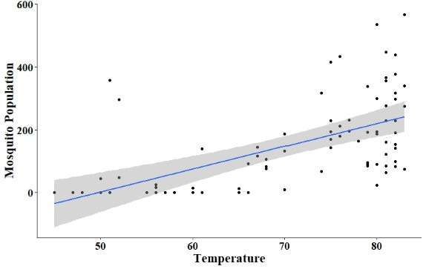

P =0.0057

**Fig. 8.** 3-D Linear model of humidity and temperature to mosquito populations. (A) 3-D Model. (B) Realtionship between mosquito population to relative humidity in this Model. (C) Relationship between mosquito population to temperature in this model.